Quick Guide:

Dos and Don’ts for a Successful Spa Loyalty Program

A good loyalty program can work wonders for your spa brand. A bad one can have the opposite effect

In order for a business to thrive, you need to both acquire new customers and retain existing ones. Research has shown that acquisition can cost between five and ten times as much as retention. A well-executed loyalty program can go a long way towards retaining those existing spa customers, as well as win new ones and enhance your brand image. According to research, 82.4% of people are more likely shop at a store with a loyalty program. A badly executed one, on the other hand, can waste time and resources and actually tarnish your brand image.

If you’re thinking of implementing a loyalty program at your spa or salon, here is a handy guide of dos and don’ts for creating, and maintaining, one that works.

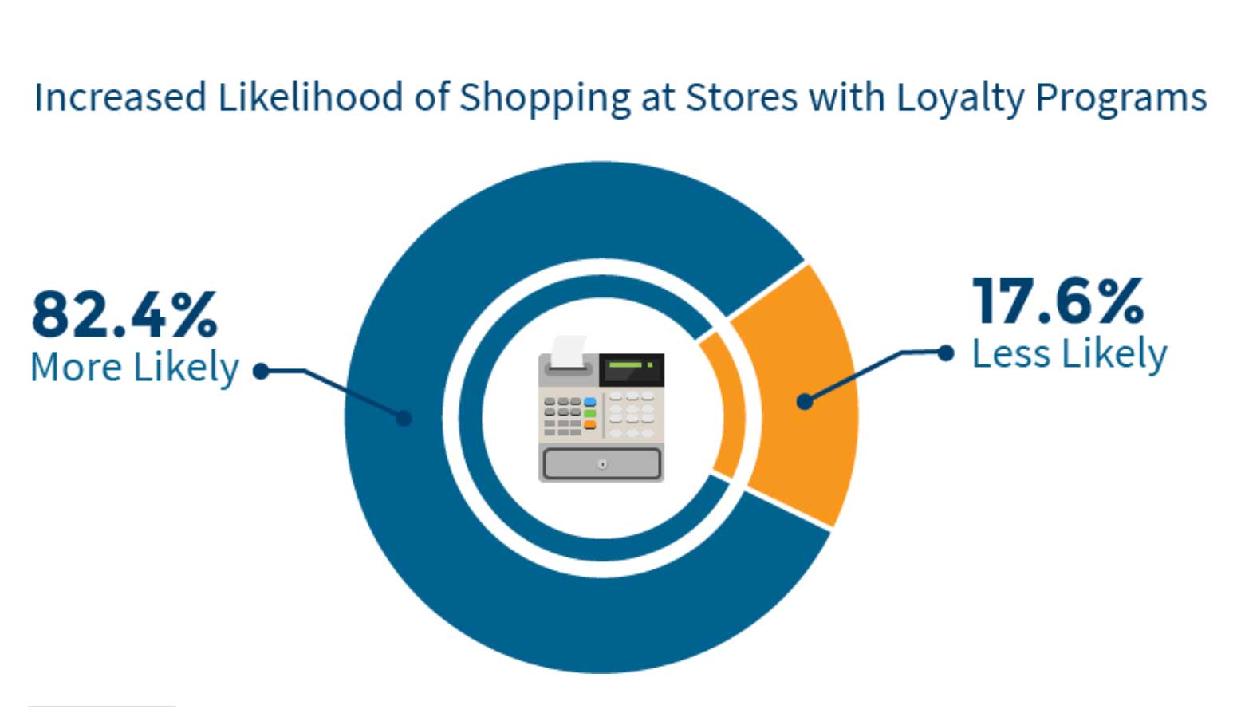
Figure 1- source Tatango

Don’t: just jump in to starting a loyalty program.

The old buy–ten-get-one-free/half-off program might work for some business models but not others. And reports suggest that engagement in those traditional loyalty programs is on the decline. You need to find out what customers want in a program before you can give it to them.

Do: do your research first

What do your customers want? Discounts, free products, VIP experiences? Affluent consumers, for example, may be less impressed with a few dollars off and more interested in time savers, emotional incentives, and exclusive access. Insights can also be gained through existing research, as well as through your own reporting and survey data. With the right spa management software your own reporting dashboard is a goldmine of information about your customers. Also, send surveys and ask customers what they would like in a loyalty program. To know what your people want, you have to ask them.

Don’t: always give away what people are already buying anyway

Joseph C. Nunes and Xavier Dreze pointed out in a 2006 Harvard Business Review article that sometimes, the only effect of a buy-ten-get-one-free program is to give away a product unnecessarily. If someone likes something enough to pay for it ten times, they’re already likely to do so an 11th time. So, there’s not much to be gained by giving it to them for free. This is an “a ha!” moment for many.

Do: consider introducing people to something new

Better than giving someone something they were already going to buy anyway, is to upsize or introduce them to something new. “Instead of giving an 11th cup free,” suggest the authors, “a coffee shop might make the tenth a larger size or throw in a free pastry. As well as being a more hedonic reward, the sample might introduce the consumer to a new product and induce higher future sales.” Consider offering a service or product they’ve never tried before, and maybe they will become a regular purchaser of that new product or service as well as the one they already love.

Don’t: stick to the status quo

According to digital consulting company, Capgemini many loyalty programs have not evolved with the digital age. Traditional loyalty programs are based on the old “spend and get” model, rewarding people for their purchase transactions. But participation rates in these programs has been on the decline for a while now. How many punch cards have you been given, and then lost over the years? Just because things have always been done one way doesn’t mean they should continue to be done that way.

Do: be innovative and take advantage of available technology

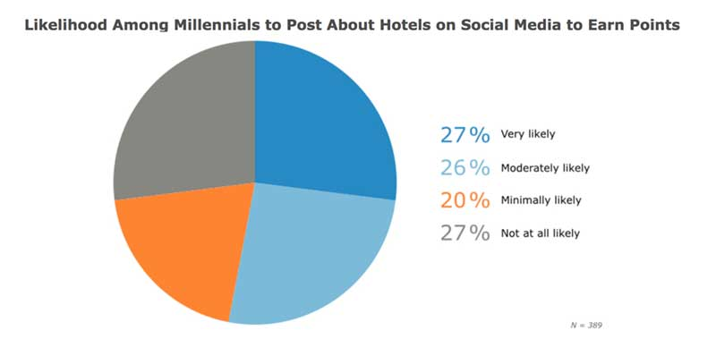
Use software to take care of your program for you. It makes no sense to expect staff and customers to keep track of points and rewards when software will do it in a fraction of the time. Technology also allows you to personalize the experience in ways that analogue never will. Offer integrated redemption across online, mobile, and offline channels. No matter what or how your customer is purchasing, loyalty points should be earned instantly and without bother.
Figure 2 - softwareadvice.com

How else can you be innovative? Multichannel loyalty and engagement solutions, for example, recognize customers for their spending, but also for social, mobile, online, and digital engagement as well. This might include rewarding customers for tweeting with a branded hashtag, sharing a post, or attending an event. Seventy-three percent of millennials are slightly to very likely to post about a hotel brand on social media to earn points. There are a lot of possibilities out there.

Don’t: follow the one size fits all model

Not everyone wants the same free massage or face cream – or even the same loyalty program model. The idea of giving everyone the same thing is outdated.

Do: personalize the experience

Personalize rewards based on purchase history, or allow customers to choose how they want to spend their reward points – as Sephora does with its immensely successful Beauty Insider loyalty program. Personalize loyalty emails and messaging as well. Personalization, as we’ve mentioned before, is the key to customer experience. Could a tiered program work for you?

Don’t: make it complicated or difficult

Making people work to earn and keep track of points, and making rewards difficult to redeem will turn them off. There are some programs out there that are infamous for making it almost impossible to redeem your rewards. Don’t do this to your valued community of customers.

Do: make sure the customer doesn’t have to work for it

A customer who uses a loyalty program already feels that they’ve earned their rewards by spending their dollars with you, rather than elsewhere. Automate the process of collecting and tracking points with your spa management software, and always offer rewards without making the customer ask for them.

Don’t: make goals difficult to reach

You don’t want people to think participating in your loyalty program looks like too much of an investment for too little reward, and therefore not worth it. It might be a little much to expect someone with a job and responsibilities to get 10 massages or facials before receiving a gift.

Do: make it easy

Give gifts along the way. Or give a head start. Research by Nunes and Dreze has shown that “artificial advancement” increases customer loyalty by 82%. In a study, car wash customers received loyalty cards. Half of the cards required eight washes to earn a free wash, while the other half required ten, but the first two were marked as a bonus head start. So, in reality both cards required eight washes but the second group got artificial advancement. Over the next nine months, 34% of people who received artificial advancement got their eight washes and earned a free wash compared with just 19% of those who did not get artificial advancement.

Don’t: think you can do things halfway

Some might think a loyalty program is easy and that you can pull the plug any time. But once it’s underway, if you decide it’s not working for you, you can’t just shut it down without potentially alienating customers and wrecking your reputation.

Do: understand that a loyalty program is a long-term commitment

This is why it’s crucial that you create a well-designed program that provides value to both you and the customer from the start. Do the research and create a great program that will not complicate your life and that will keep your customers coming back.

Published by Book4Time, the world’s most innovative spa management software.

